**Milestone 4: Baseline Model Trials:**

**Baseline Models:**

1. Mean Predictor:

The mean model predicts the average value of goals scored by each player. It's a simple but essential baseline to compare whether more complex models, add better predictive validity, beyond basic averages.

1. Multilinear Regression:

The Multilinear Regression model was selected to assess the correlation of multiple independent variables (eg. Shots on target, Expected Goals etc.) in relation to our target variable (Goals Scored). It provides an essential baseline to help us understand the relationship of the dependent variable and the predictors, assuming that there is a linear relationship between them.

**Model Performance:**

1. Multilinear Regression:

This model performed moderately well, showing that the data follows a linear pattern. However, the RMSE we not always low, indicating that the model is not able to capture all complexities.

1. Mean Predictor:

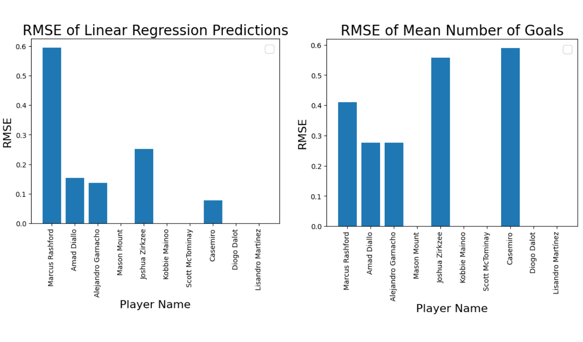This model had a higher error, as expected, in most predictions, reinforcing the value of more complex models.

**Key Learnings and Next Steps:**

1. The multilinear regression model assures us that there is some linear relationship in the data, but there is room for improvement, since some RMSE values are still bigger than one.
2. The gap between the RMSE of the mean predictor and the multilinear regression predictor shows us that the rest of the features contribute positively into the predictions.

**Next Steps:**

* We will explore also non linear models to capture more complex patterns
* We will preform cross validation to evaluate our model
* We will use more complex models like Decision Trees to make our predictions